Requirements for Semantic Grounding of SIMF Rules

V0.1 - 6/23/2016

## Overview

Semantic Information Modeling for Federation (SIMF) requires a firmer semantic grounding, in particular for rules. The design goals for SIMF are focused on semantic mediation of arbitrary data structures. Semantic mediation is based on conceptual models being the “pivot point” between data structures where the mapping between them is defined using rules. In addition, rules are used as the basis for limited inference supporting conceptual model semantics. By rules we mean the specific rule kinds defined in SIMF.

As the SIMF language is intended to be used for conceptual modeling with minimal restrictions on stakeholder’s conceptions, these models frequently use higher order logic, as the world we represent is higher order. This higher order capability comes with limitations on efficient inference capabilities, which are those that can be implemented with the rules as specified.

We are seeking advice on the best language to use for the semantic grounding of these rules such that the rules can be executed. For details on the current SIMF specification see: <https://github.com/ModelDriven/SIMF/tree/master/NextSubmission>

In addition to advice on the language for grounding rules, suggestions are welcome for other refinements to SIMF to achieve the stated goals.

## Models over which rules will be operating

The SIMF meta model describes the language structure and semantics. This language includes context, situations and first-class n-ary Relationship Types (i.e., having multiple Properties), as can be seen in the following diagram:

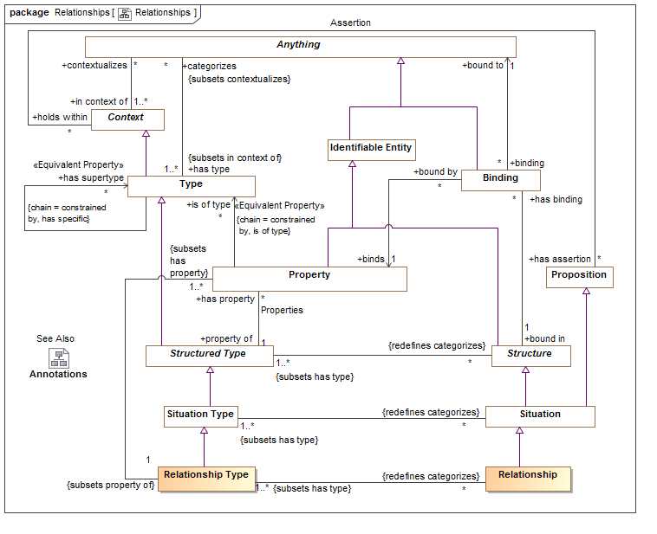

The reader is referred to the specification for details. What should be noted is the use of Context (see upper-left in diagram) as the binding between Propositions (has assertion, shown middle right in diagram) and what they contextualize (contextualizes, shown upper-left in diagram) and the definition of relationships as first-class (relationships may participate in other relationships and be in specific time and other context). This is the structure over which SIMF rules will be operating. Also note that rules are themselves a subtype of Proposition, and thus rules may be contextualized and subject to other rules.

## Rules for defining conceptual models

SIMF defines a set of rule kinds that are used to define domain and information models. Most of these rules will be familiar as common model semantics and shall cover:

* Enumeration (Can apply to any context, closes the world)
* Equivalence (Can be applied to any context)
* Disjointness
* Conditions (expressions)
* Pattern rules (including quantified variables) – this is the most general rule kind
* Rules about types
  1. Type Generalization constraint
  2. Multiplicity constraint
  3. Covering constraint
  4. Uniqueness constraint
* Rules about properties
  1. Property Generalization constraint
  2. Property type constraint
  3. Property transitivity constraint

Diagrams for these rules are provided below, but the reader is referred to the specification for details.

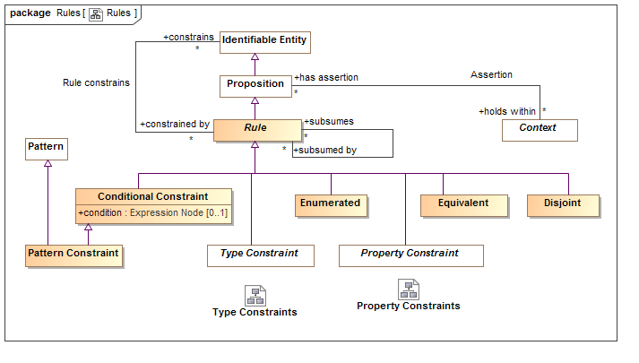

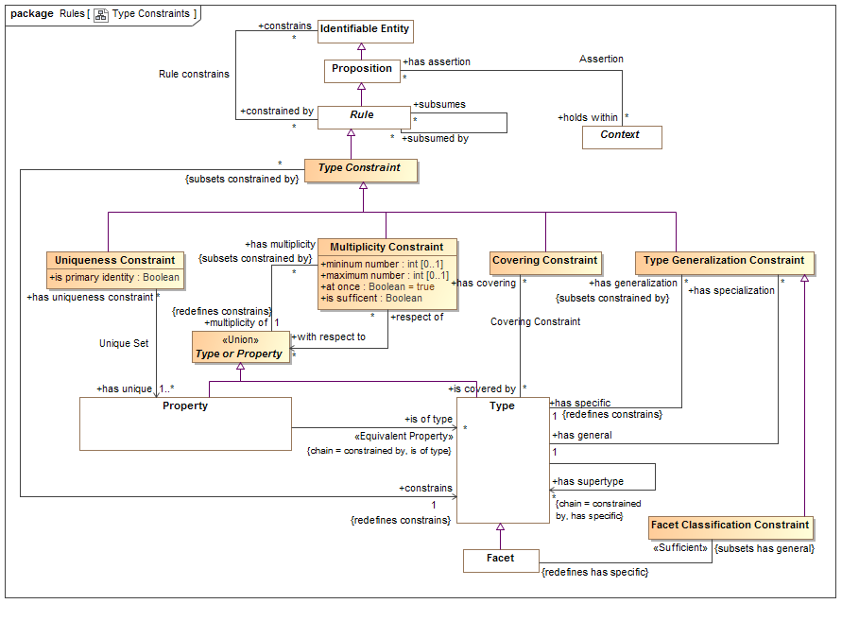

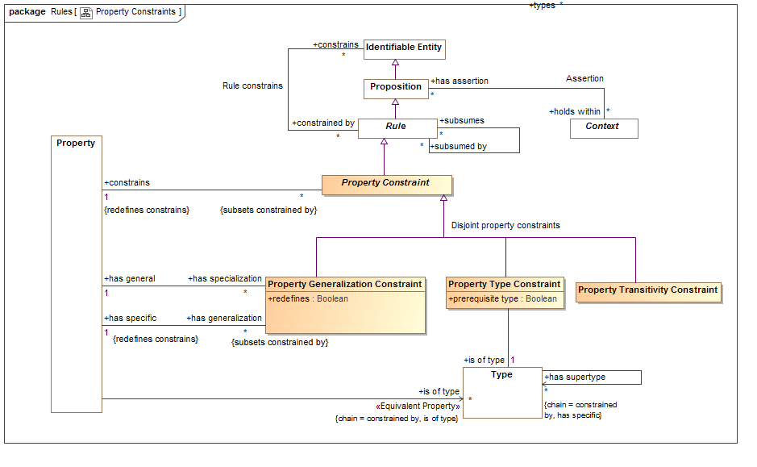

## Mapping rules

Rules for mapping are based on patterns and mapping between patterns. Mapping rules implement a mapping by asserting the entities and relationships required to make a pattern true. The following diagram shows the mapping rules and patterns that they utilize:

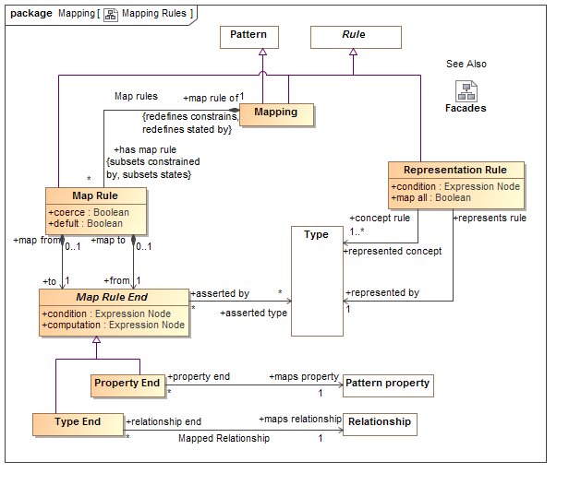

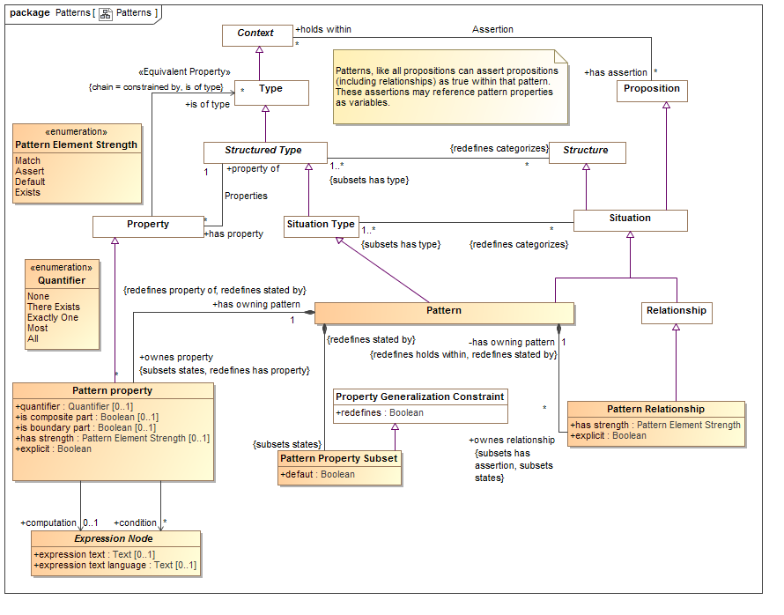

Representation rules provide a high-level view of what information model types represent what concept types, however any two types may play the roles of what is the concept and what is the representation. Representation rules also constrain map rules – a type can only map to what it represents (however there is an override for this). Patterns provide for complex paths through models such that mappings do not have to be 1:1.

Note also that patterns provide a “match” capability which defines the conditions that will “fire” the rule (the head) for the other properties and relations specified (the body). The head is defined as all elements with a “has strength” of “Match”.

Within a mapping rule there is a pattern and set of map rules. Each map rule defines a correspondence between a representation and a concept. Map rules are the basis for information federation. The map rule must maintain this correspondence, bidirectionaly.

## Non requirements

While the rules as specified could be used for general inference, the requirements for SIMF inference are limited to those required for the SIMF use cases of federation.

**The required semantics of rules is limited to forward chaining**. Other than the implication of the rule, rules are not required to infer other rules to make a model consistent. Advanced logics *may* provide additional capabilities but those capabilities are not required by SIMF. For example, it is not required that two identities be asserted to be the same individual to satisfy a model – in many cases such situations are errors and *may* be flagged as such.

Mappings to other languages providing for inference *may* use patterns such that those logics are better able to make inferences implied by SIMF rules.

SIMF does not define a general rules language, optional extensions could be defined for such general rules.

## Summary

In summary, the language for grounding SIMF rules must be able to:

* Operate over SIMF context and relationships
* Be contextualized and subject to other rules
* The rules to be implemented are those specified above as subtypes of “Rule”

The SIMF RFP requires semantic grounding of the SIMF language. We are soliciting input as to the best language with which to formalize the SIMF rules and any assistance as can be provided for such grounding. Such a language should also allow execution and validation of rules and models containing rules, even if such execution is not optimal.